Working Document
  - IT-1B Hardware Department

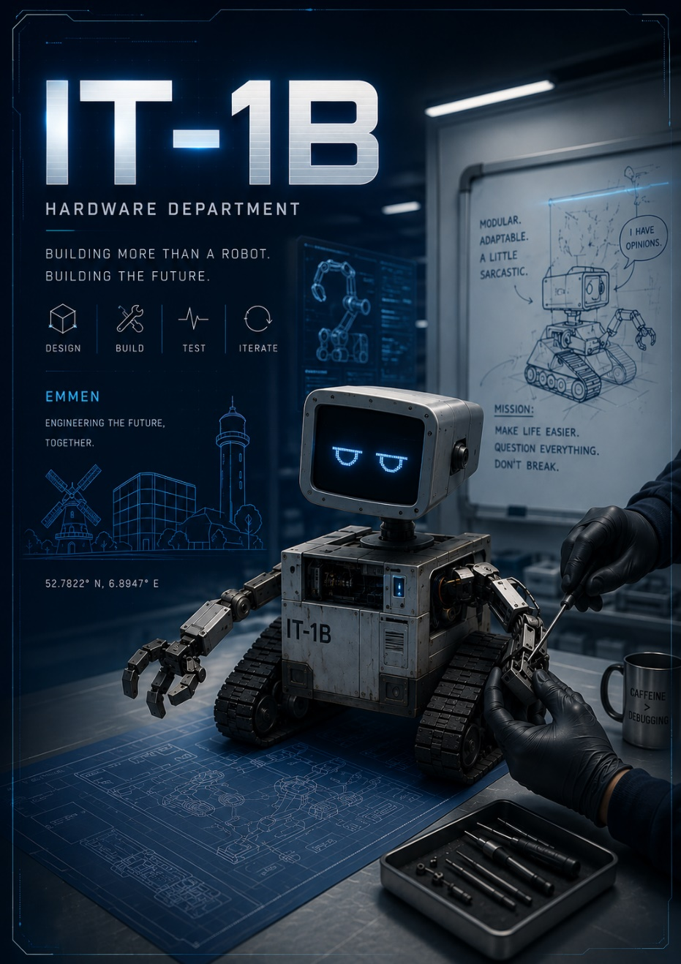

To the reader:
This document has been created to inform both the other departments as well as the assessors of this course the work that has been done during the 8 weeks period. This document has been created, edited and updated by:
Kyra Kovács (5635810) & Herbert Dorothea (5753732)
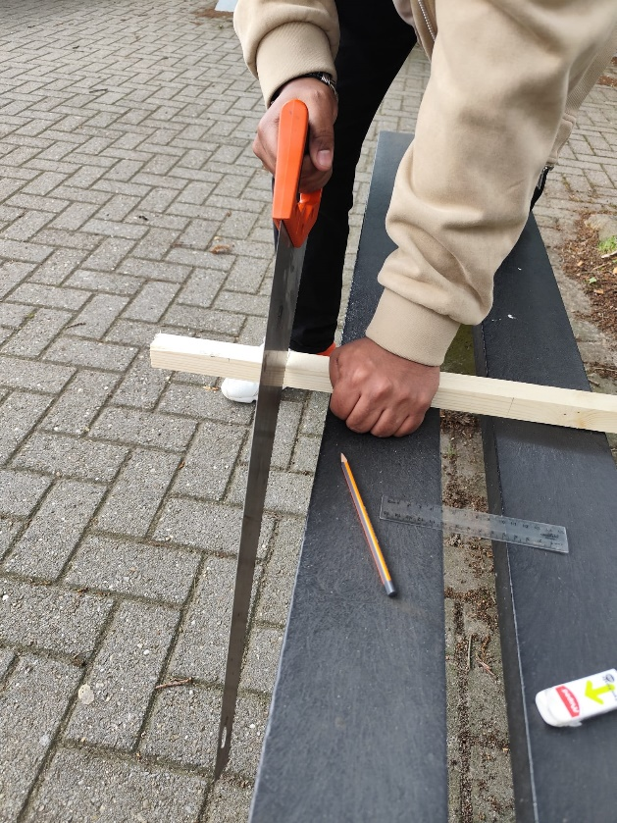
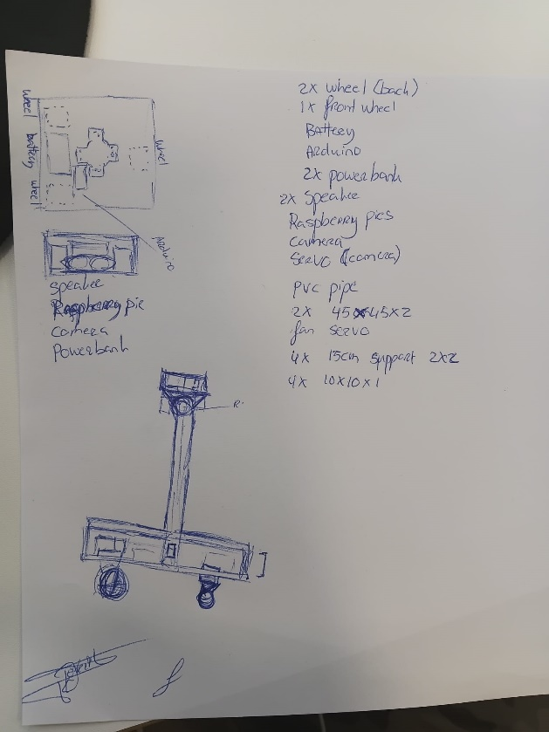

The Image (left above) illustrates the original idea for the creation of the EmotiBot with potential parts we might need or use.
The Image (right above) above is the moment where the supporting borders where being sawed.
The Image (left below) is the process of measuring the area where the back tires should go.
The Image (right below) is the process of measuring the area and the supporting blocks where the front wheel should be.
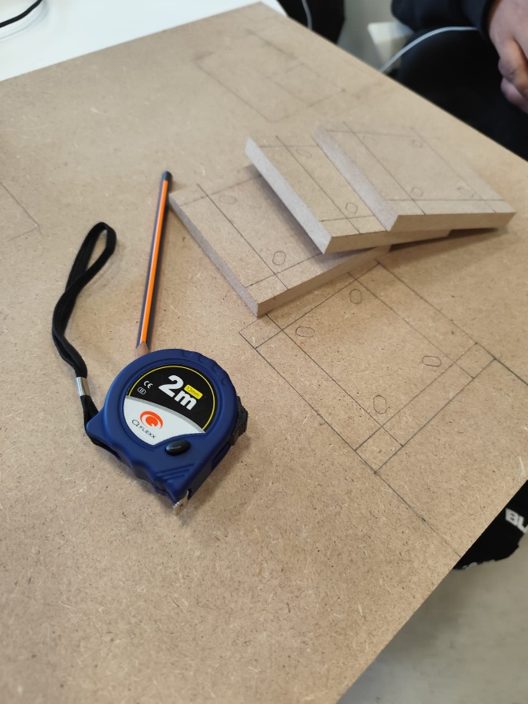
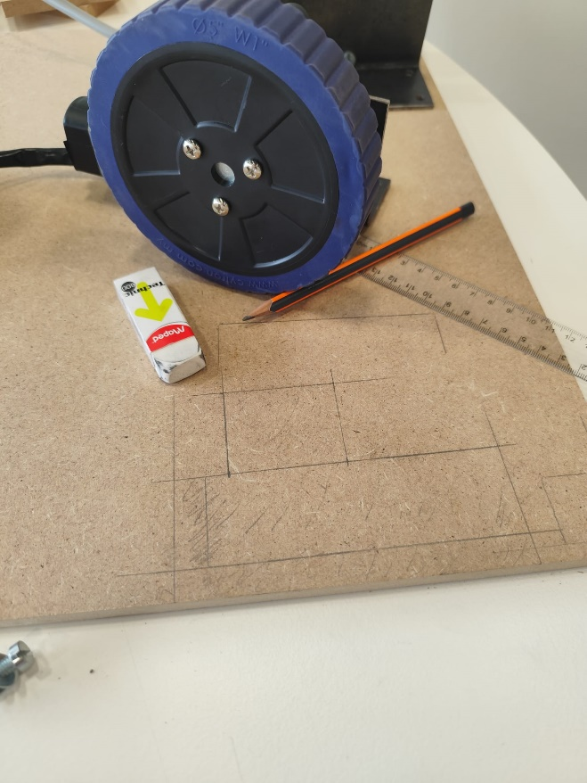

All Images below are from the attachment process of the wheels and the inclusion of the pole and the supporting barriers. The steps done to complete these tasks included: Measuring, drawing, cutting, drilling, attach, screwed, etc.

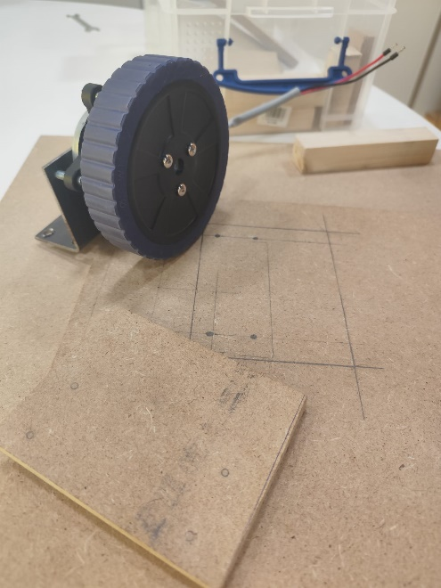

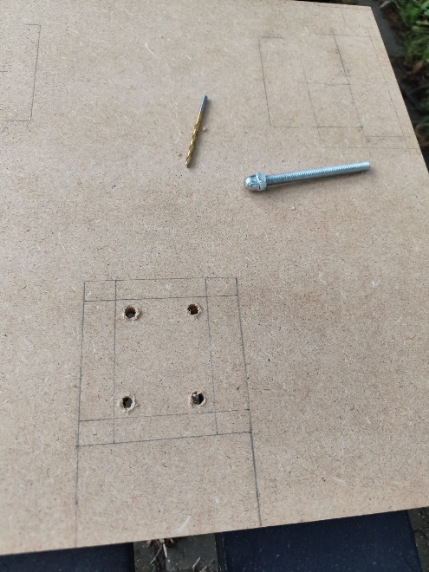
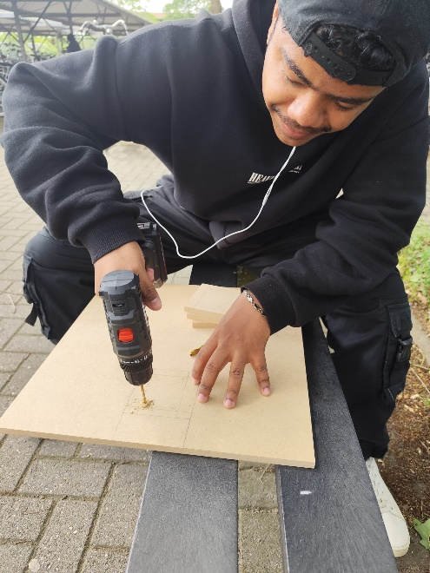

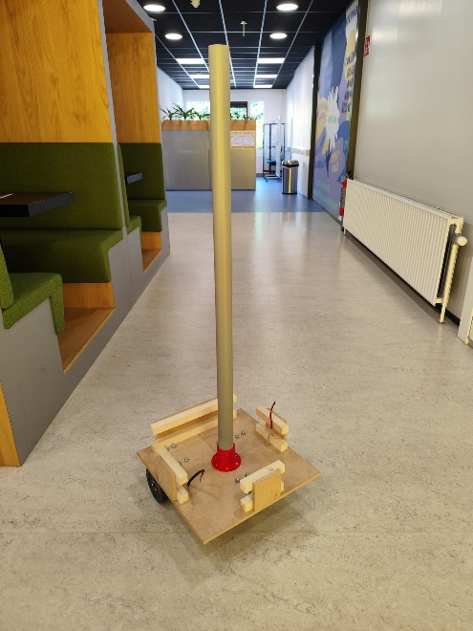

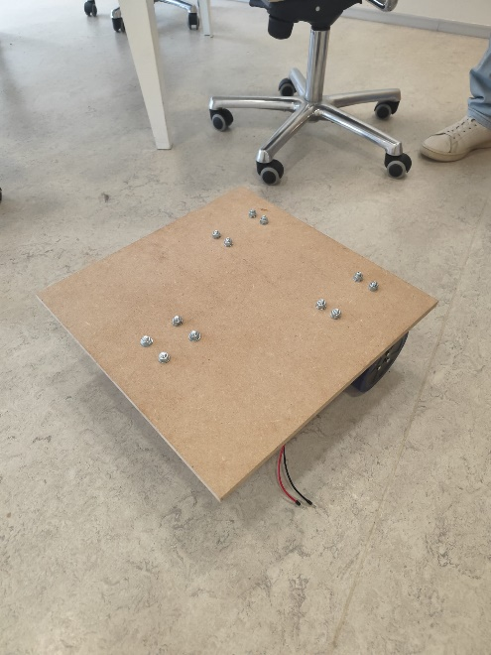

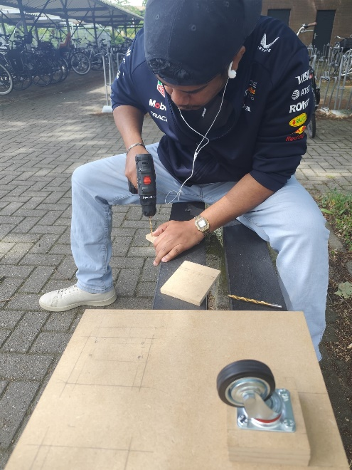

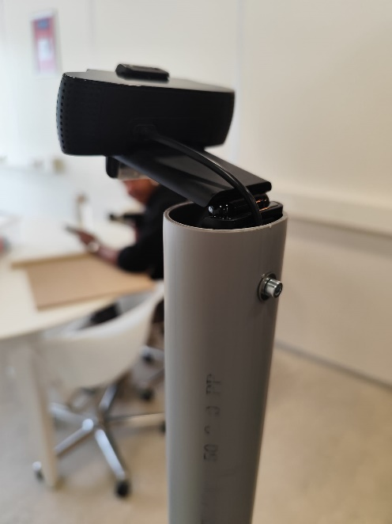
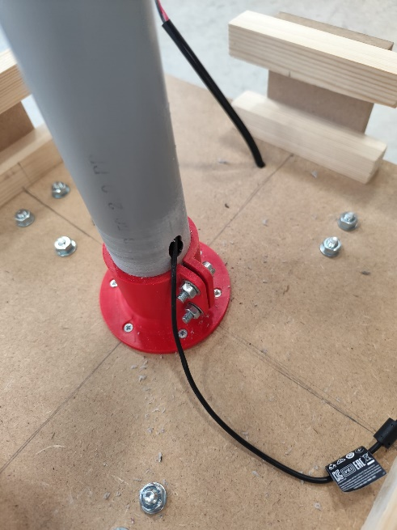
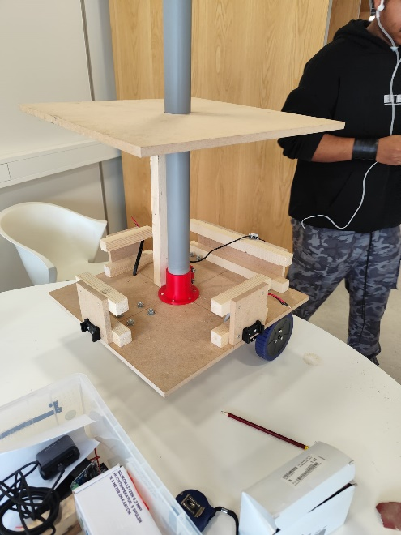
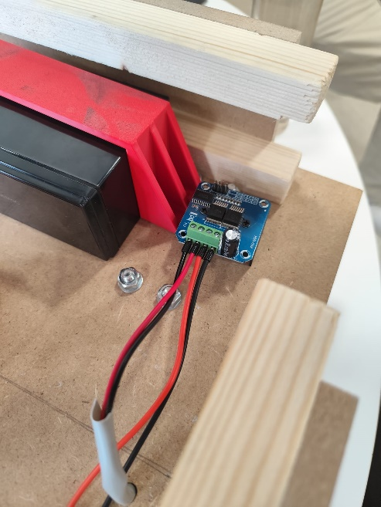
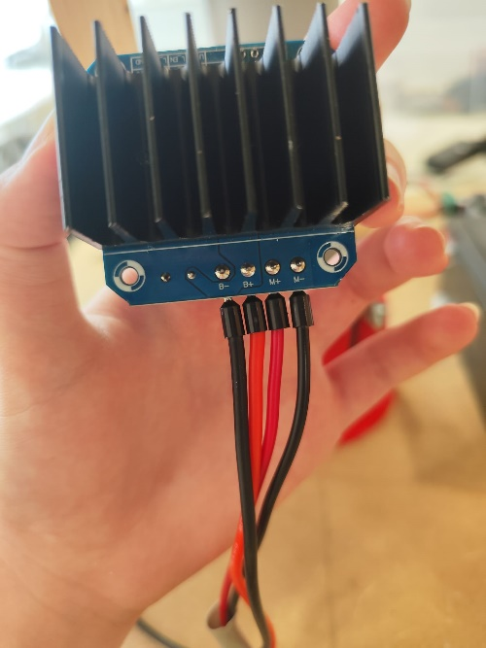
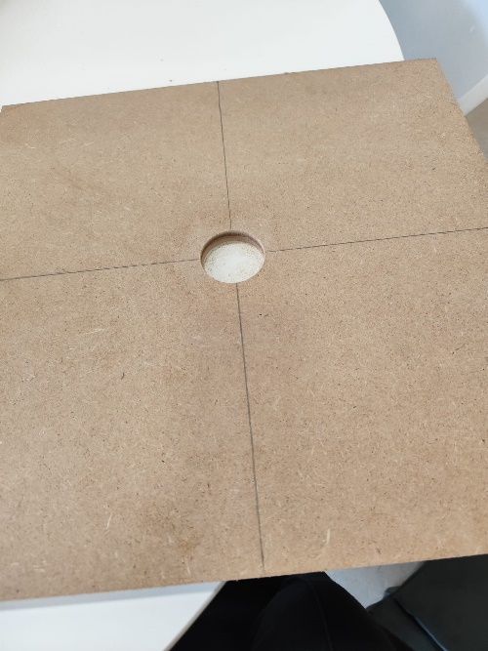
Below is the process of attaching the camera, feeding the wire by making a hole at the bottom, creating a hole in the top part of the case/chassis, attaching them all together. The last two pictures show the process of connecting the motors to the battery.

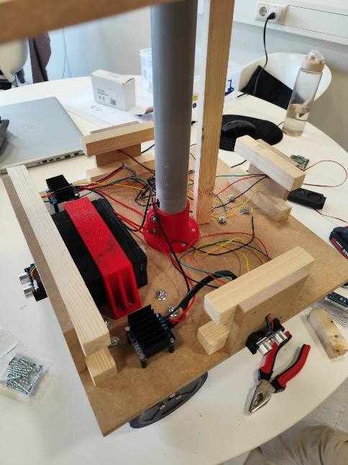
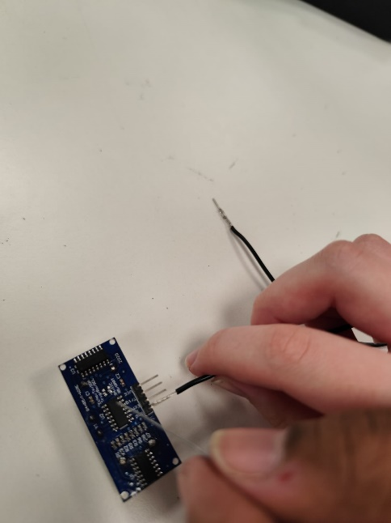
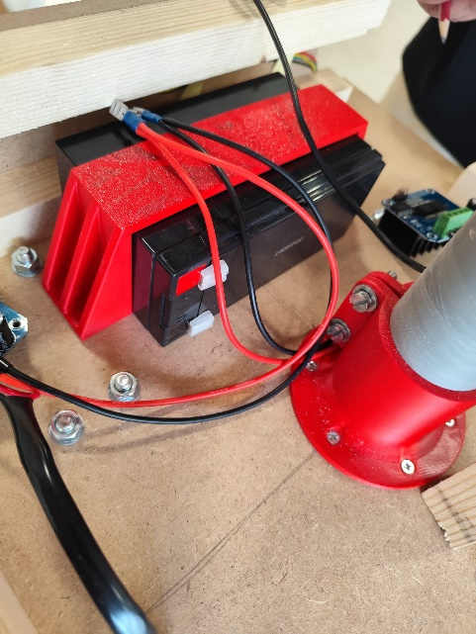
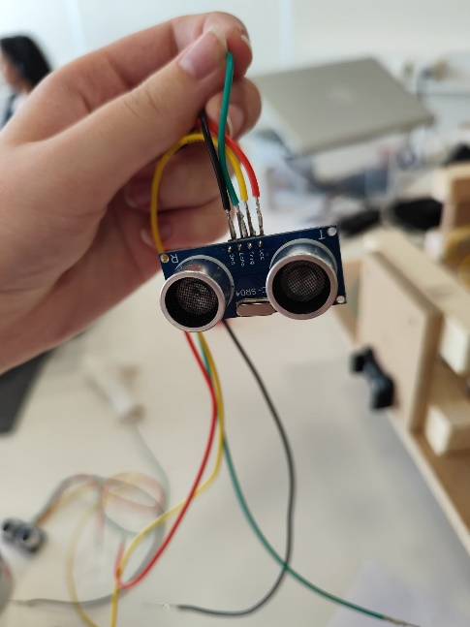
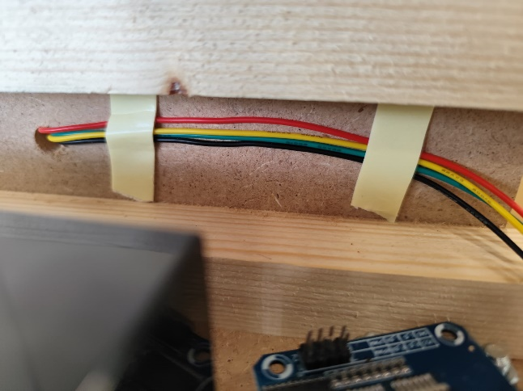
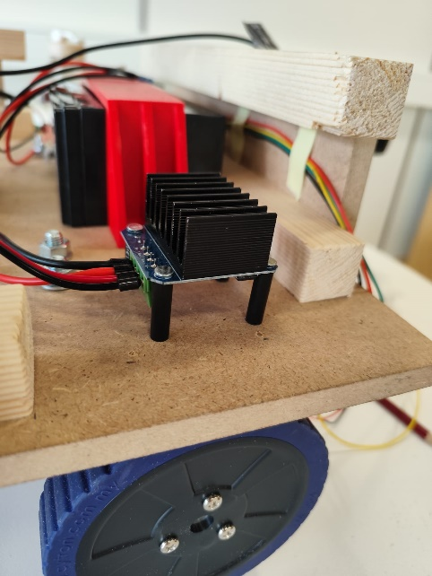
Soldering the wires to the Ultrasonic Distance sensors, placing them correctly on the wooden plate with double sided tape and connecting it all to the breadboard.
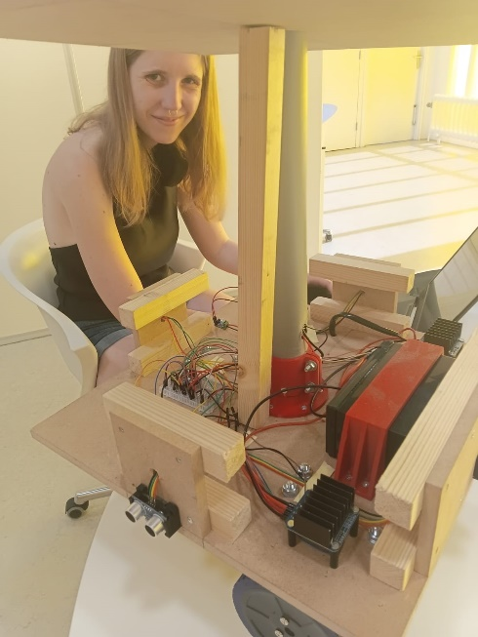
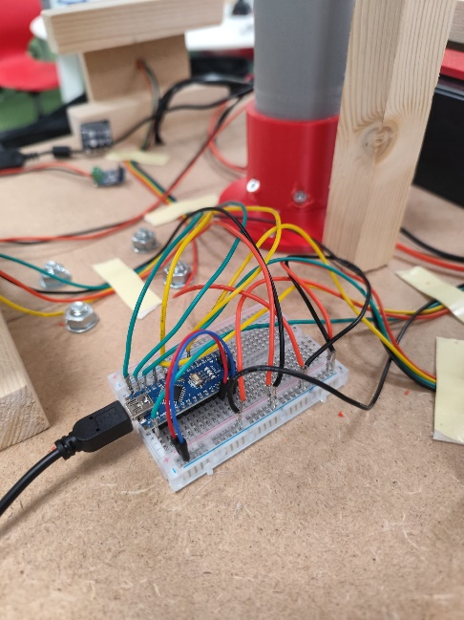
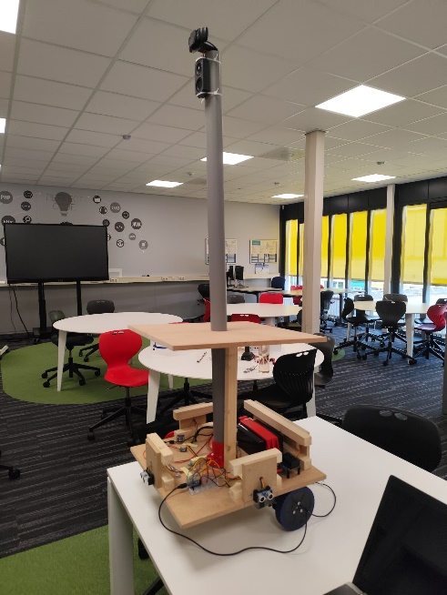
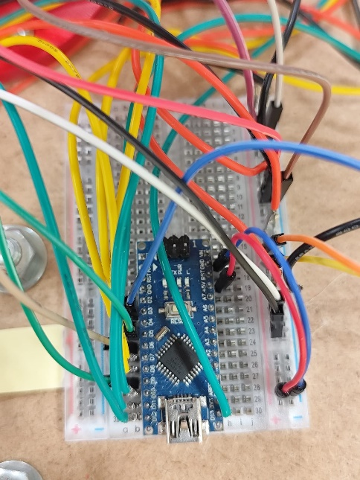
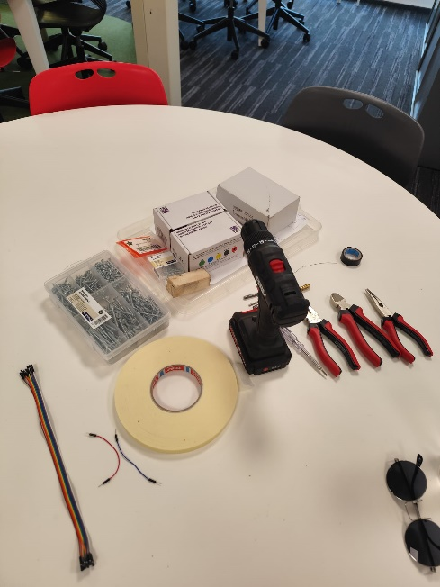
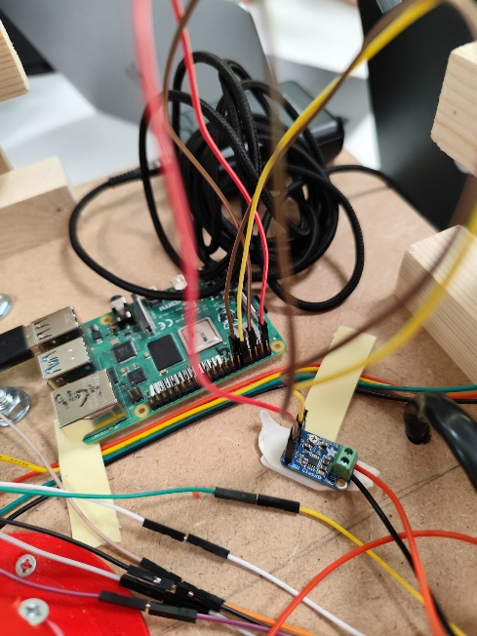
The images below show the final process before the ending the hardware process and all its components. We connected all the motor driver wires, ultrasonic distance wires and the Adafruit with the Raspberry Pi.

Kyra Kovács (Left Up) - Herbert Dorothea (Middle Up) - Jessica Camacho (Right Up)
Ngangfor Sustain (Bottom Left) - Franz Petev (Bottom Middle) - Kristian Endrev (Bottom Right)

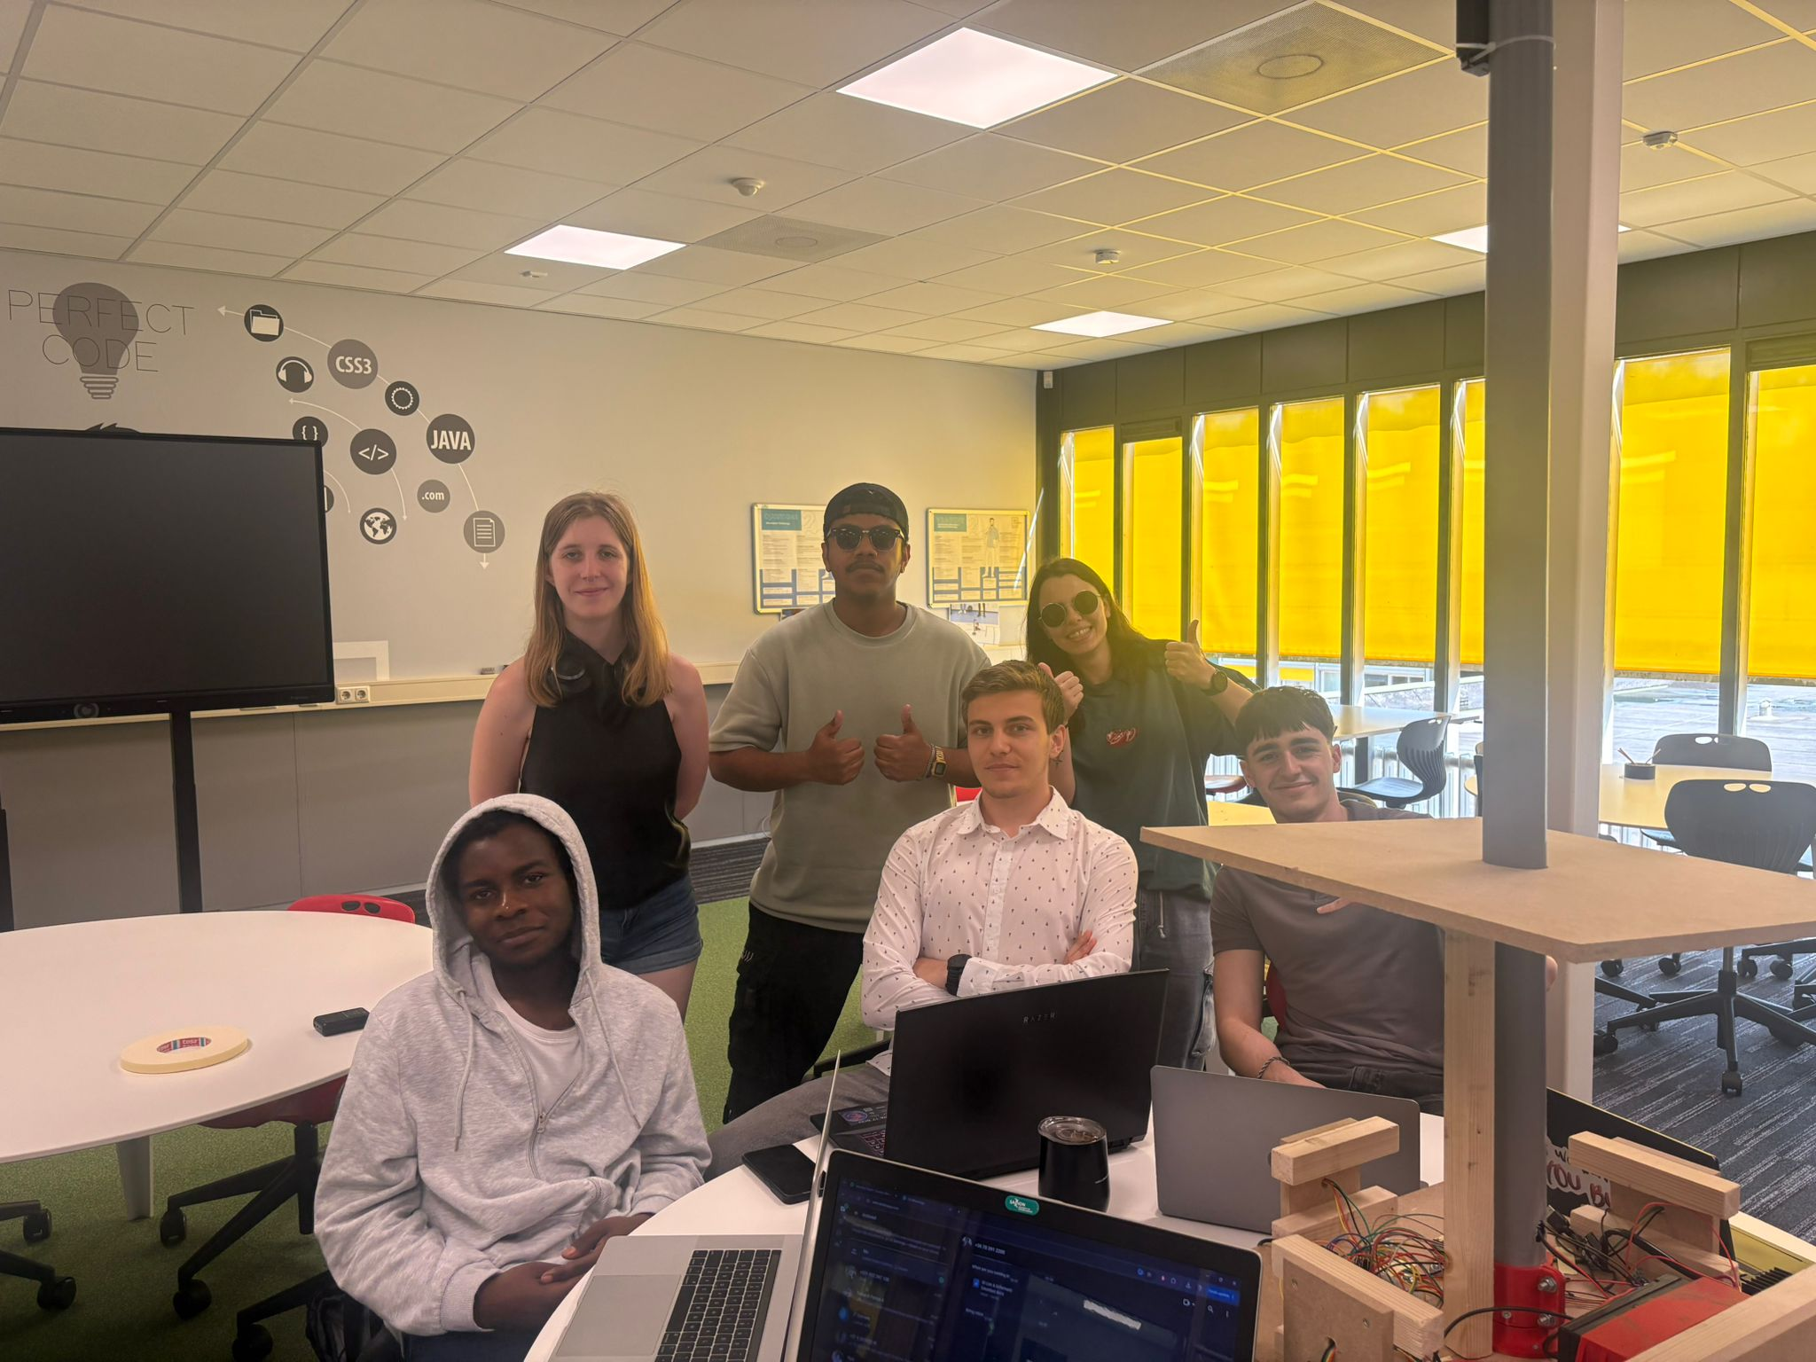

  - List of components used for this project

- 2 Back Wheels with motor
- Front Wheel
- Lithium Battery
- 2 Motor Drivers
- Power Bank
- Raspberry Pi 4
- Sound Module Adafruit
- Arduino Nano
- Breadboard Half
- Pipe Base 50mm
- PVC Pipe 50mm
- 2 Wooden Planks 45x45x1
- 4 Wooden Supporting Pieces 10x10x1
- 4 Wooden Supporting Pieces 15x2x2
- Camera Webcam
- Speaker
- 4 Ultrasonic Distance Sensors
- 16 Silicone Wires connected to the Ultrasonic Distance Sensors
- 24 Male to Female Wires from Motor Drivers to Breadboard
- 2 Silicone Wires from Speaker to AdaFruit Sound Module
- 4 Female to Female Wires from the AdaFruit Sound Module to the Raspberry Pi
- 4 Silicone Wires from Motor Driver to the Lithium Battery
- 2 Male to Male Wires from the Arduino Nano to the Breadboard
- USB C to USB C Raspberry Pi to the Power Bank
- USB A to Micro USB Arduino Nano to the Power Bank

